>>>>>Test Cases<<<<<

VALID 1:
#HAI
#MAEK HEAD
#GIMMEH TITLE The Simpsons #OIC
#MKAY
#MAEK PARAGRAF
Hi #GIMMEH BOLD Homer #OIC #NEWLINE
#GIMMEH LINX www.towson.edu #OIC
#MKAY
#KBYE

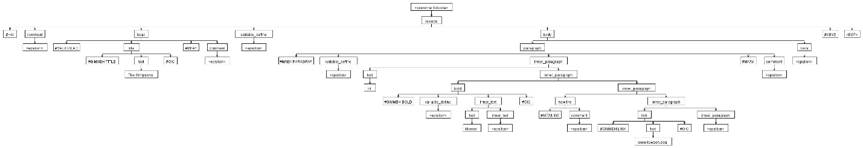

VALID 2:
#HAI
#IHAZ lastname #ITIZ Simpson #MKAY
#MAEK PARAGRAF
#GIMMEH BOLD #GIMMEH VAR lastname #OIC #OIC
#MAEK LIST
#GIMMEH ITEM Homer #OIC
#GIMMEH ITEM Marge #OIC
#MKAY
#MKAY
#KBYE
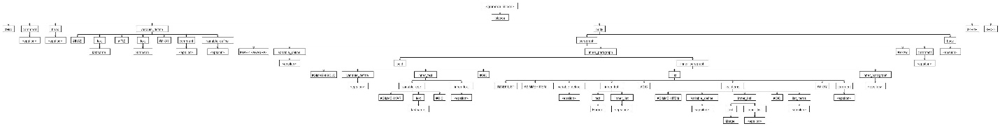

INVALID 1:
#HAI
#MAEK PARAGRAF
Outer
#MAEK PARAGRAF Inner #MKAY
#MKAY
#KBYE
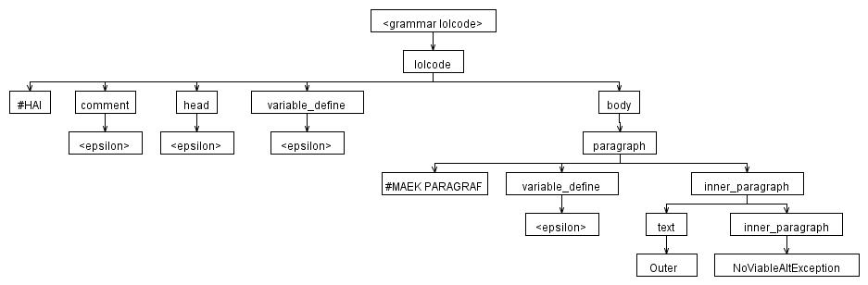

INVALID 2:
#HAI
#MAEK LIST
Homer
#MKAY
#KBYE



